JavaScript Coding Fun

[Perimeter of squares in a rectangle](https://www.codewars.com/kata/559a28007caad2ac4e000083)

The drawing shows 6 squares the sides of which have a length of 1, 1, 2, 3, 5, 8. It's easy to see that the sum of the perimeters of these squares is : 4 * (1 + 1 + 2 + 3 + 5 + 8) = 4 * 20 = 80

Could you give the sum of the perimeters of all the squares in a rectangle when there are n + 1 squares disposed in the same manner as in the drawing:

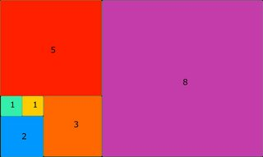

#Hint: See Fibonacci sequence

#Ref: <http://oeis.org/A000045>

The function perimeter has for parameter n where n + 1 is the number of squares (they are numbered from 0 to n) and returns the total perimeter of all the squares.

perimeter(5) should return 80

perimeter(7) should return 216

Solution:

**function perimeter(n) {**

**let arr = [1, 1];**

**for(let i = 0; i < n - 1; i++) {**

**arr.push(arr[arr.length - 1] + arr[arr.length - 2]);**

**}**

**return 4 * arr.reduce((sum, num) => sum + num, 0);**

**function perimeter(n) {**

**let arr = [1, 1];**

**for(let i = 0; i < n - 1; i++) {**

**arr.push(arr[arr.length - 1] + arr[arr.length - 2]);**

**}**

**return 4 * arr.reduce((sum, num) => sum + num, 0);**

**}**

**}**

Bit Counting

Write a function that takes an (unsigned) integer as input, and returns the number of bits that are equal to one in the binary representation of that number.

*Example*: The binary representation of 1234 is 10011010010, so the function should return 5 in this case

Solution:

**countBits =** n => **n.toString(**2**).split(**'0'**).join(**''**).length;**

**function countBits(n) {**

**for(c=0;n;n>>=1)c+=n&1**

**return c;**

**}**